

**SCHOOL OF COMPUTER SCIENCE ENGINEERING**

**AND INFORMATION SYSTEMS**

**VALUE ADDED COURSE**

**ON**

**NETWORKING CARDINCALS**

**ASSESSMENT**

**SUBMITTED ON: 22 – SEP - 2024**

**SUBMITTED BY-**

**AKASH KUMAR BANIK**

**PROGRAM: MCA**

**REGISTER No.: 24MCA0242**

Q1. Create a network with 15 computers using mesh topology. Show the sample screenshots (5 instances) for sending a packet from PC1 to PC9.

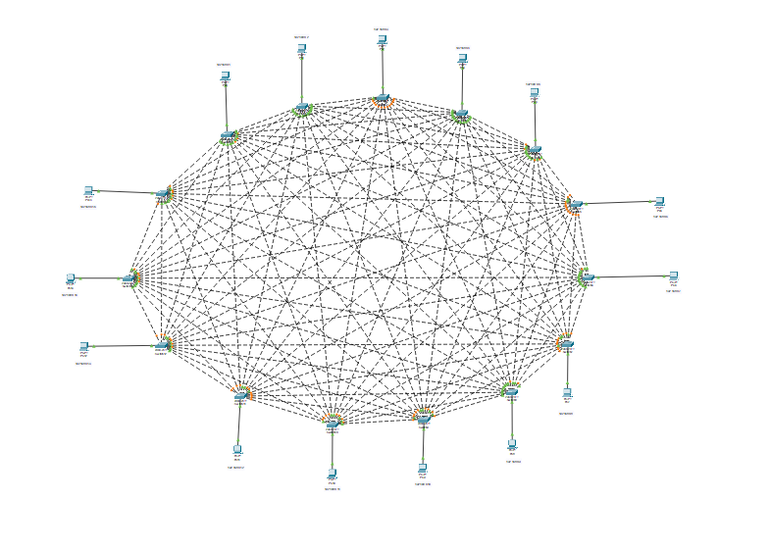

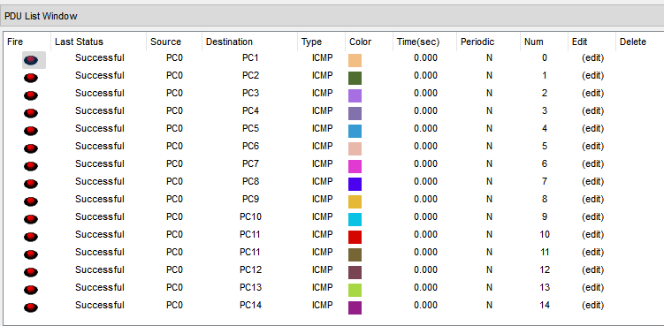

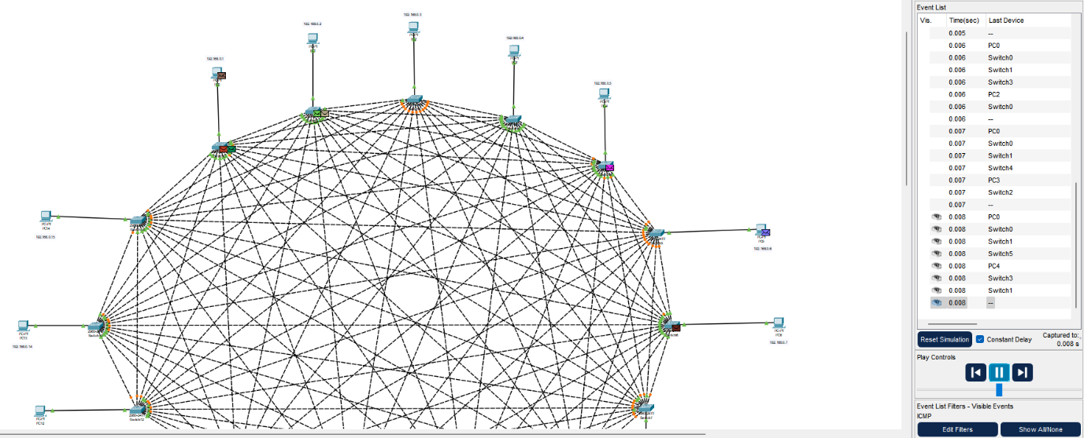

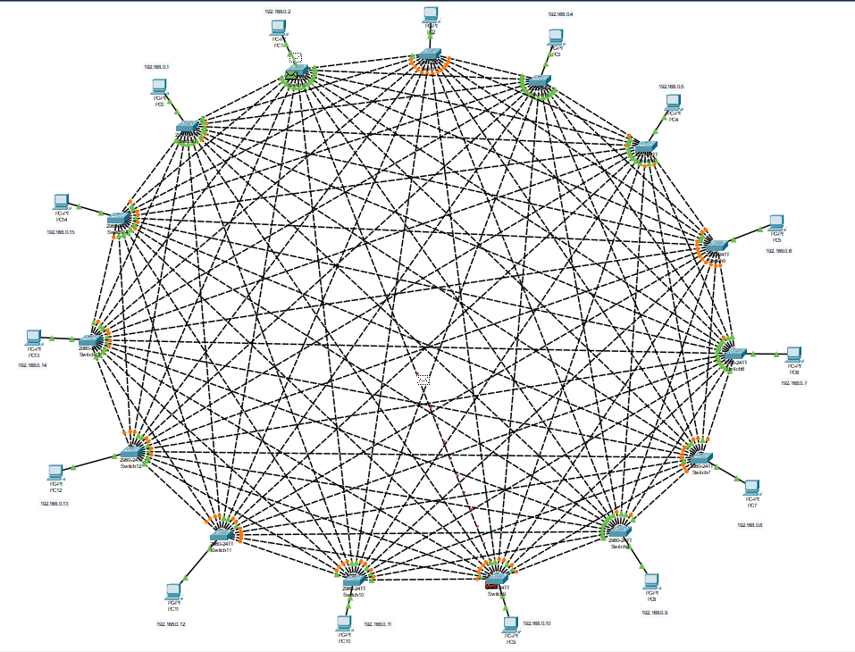

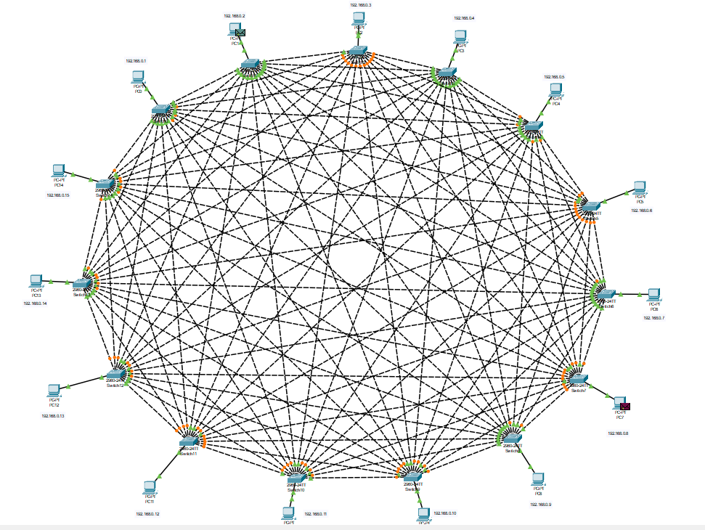

Q2. Implement Dynamic NAT for 5 computers, 2 switches, 2 routers, and 1 server. Show the sample screenshots (5 instances) for sending a packet from PC2 to Server.

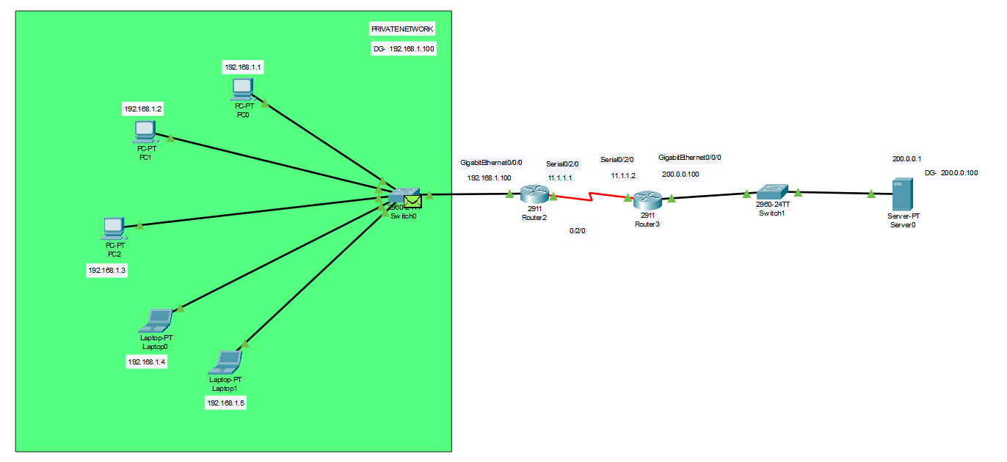

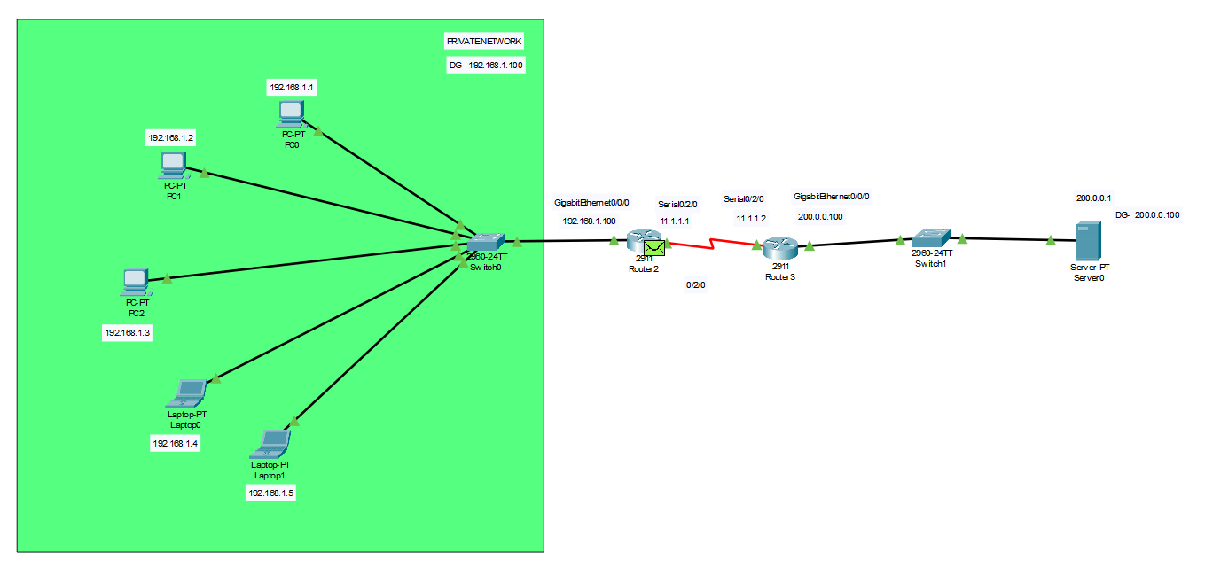

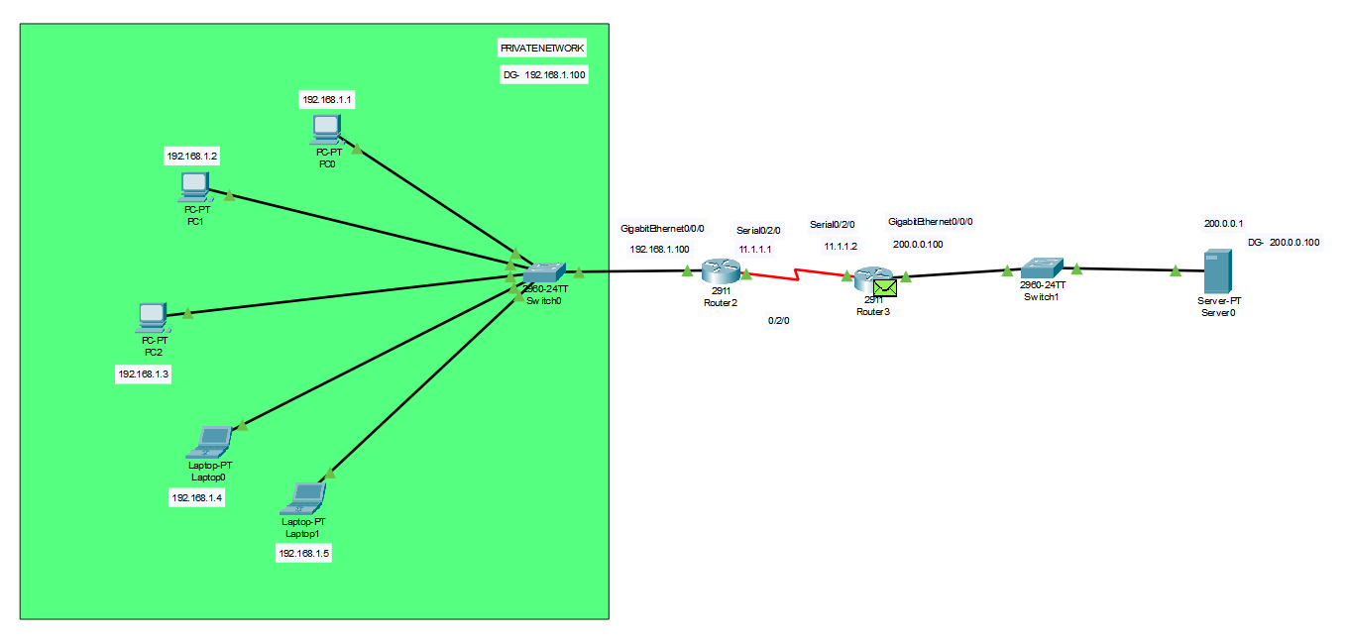

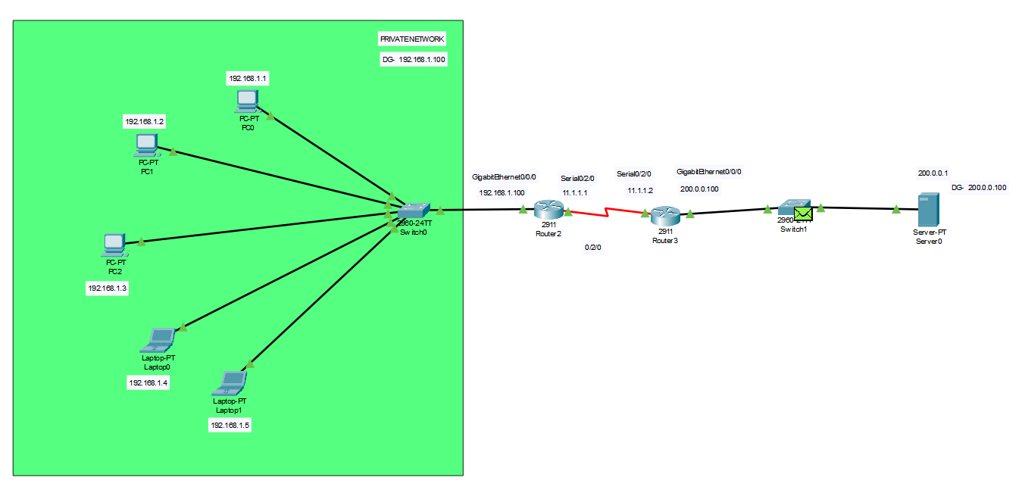

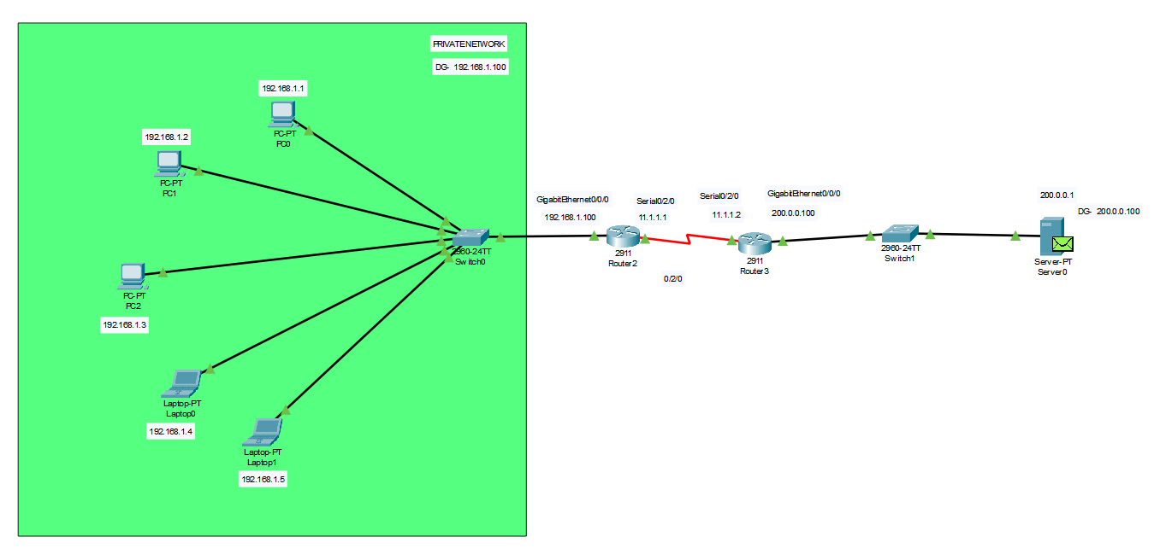

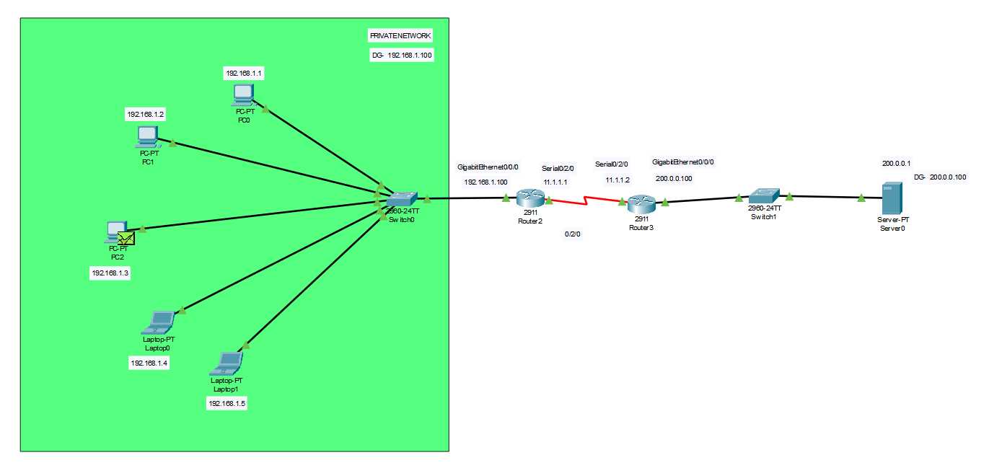

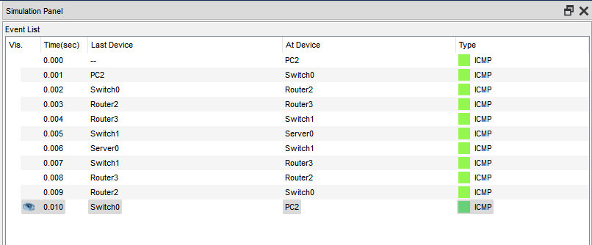

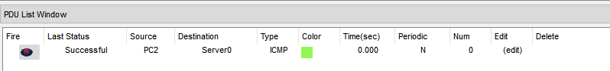

Q3. Implement TCP protocol for 4 computers (DNS Client, HTTP Client, FTP Client, Email Client), 1 switch and 1 multi server. Show the communication between all clients with the multi-server (2 instances).

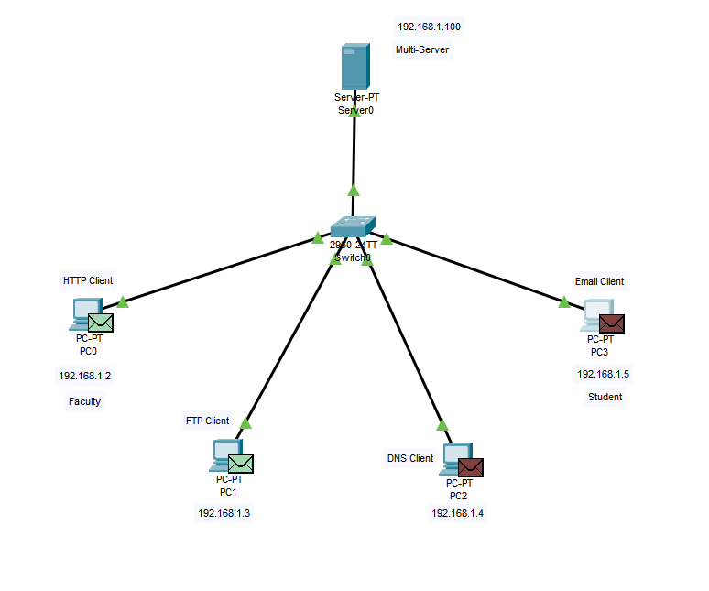

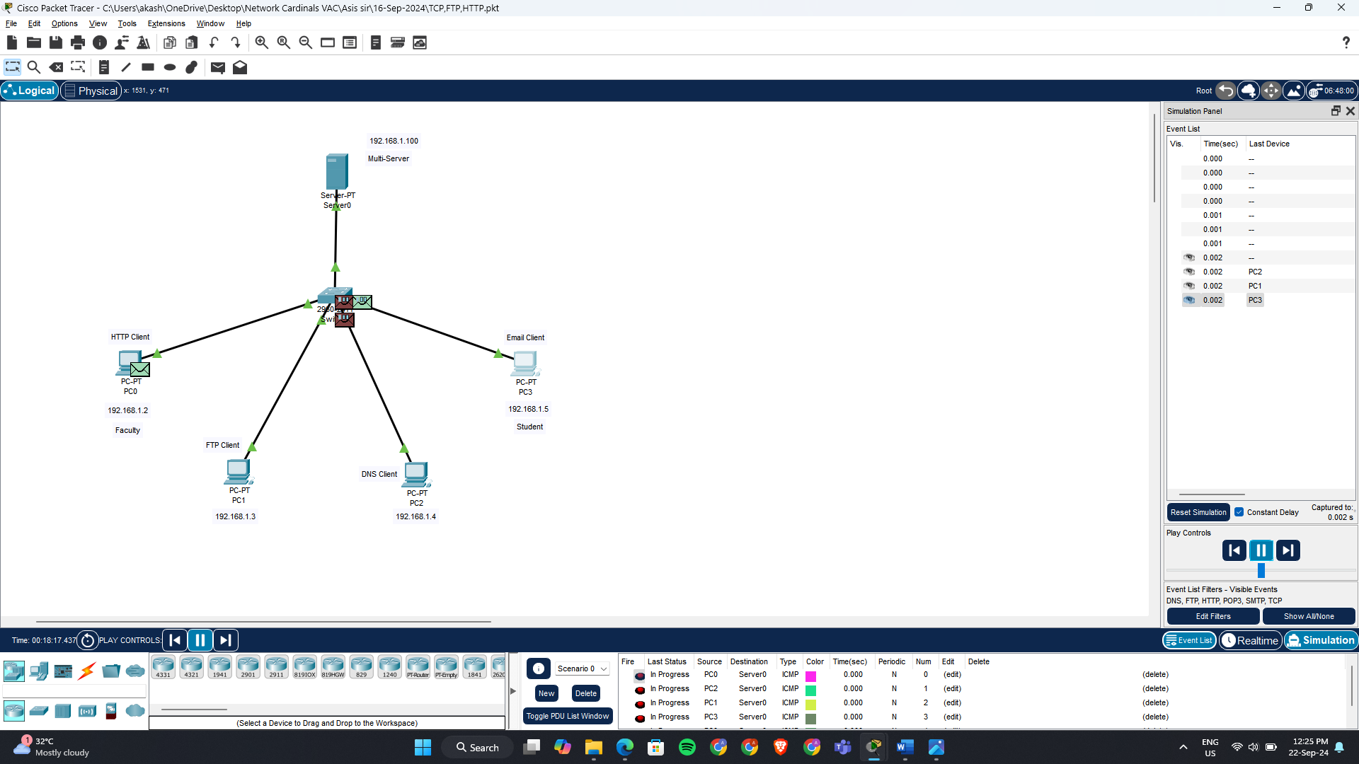

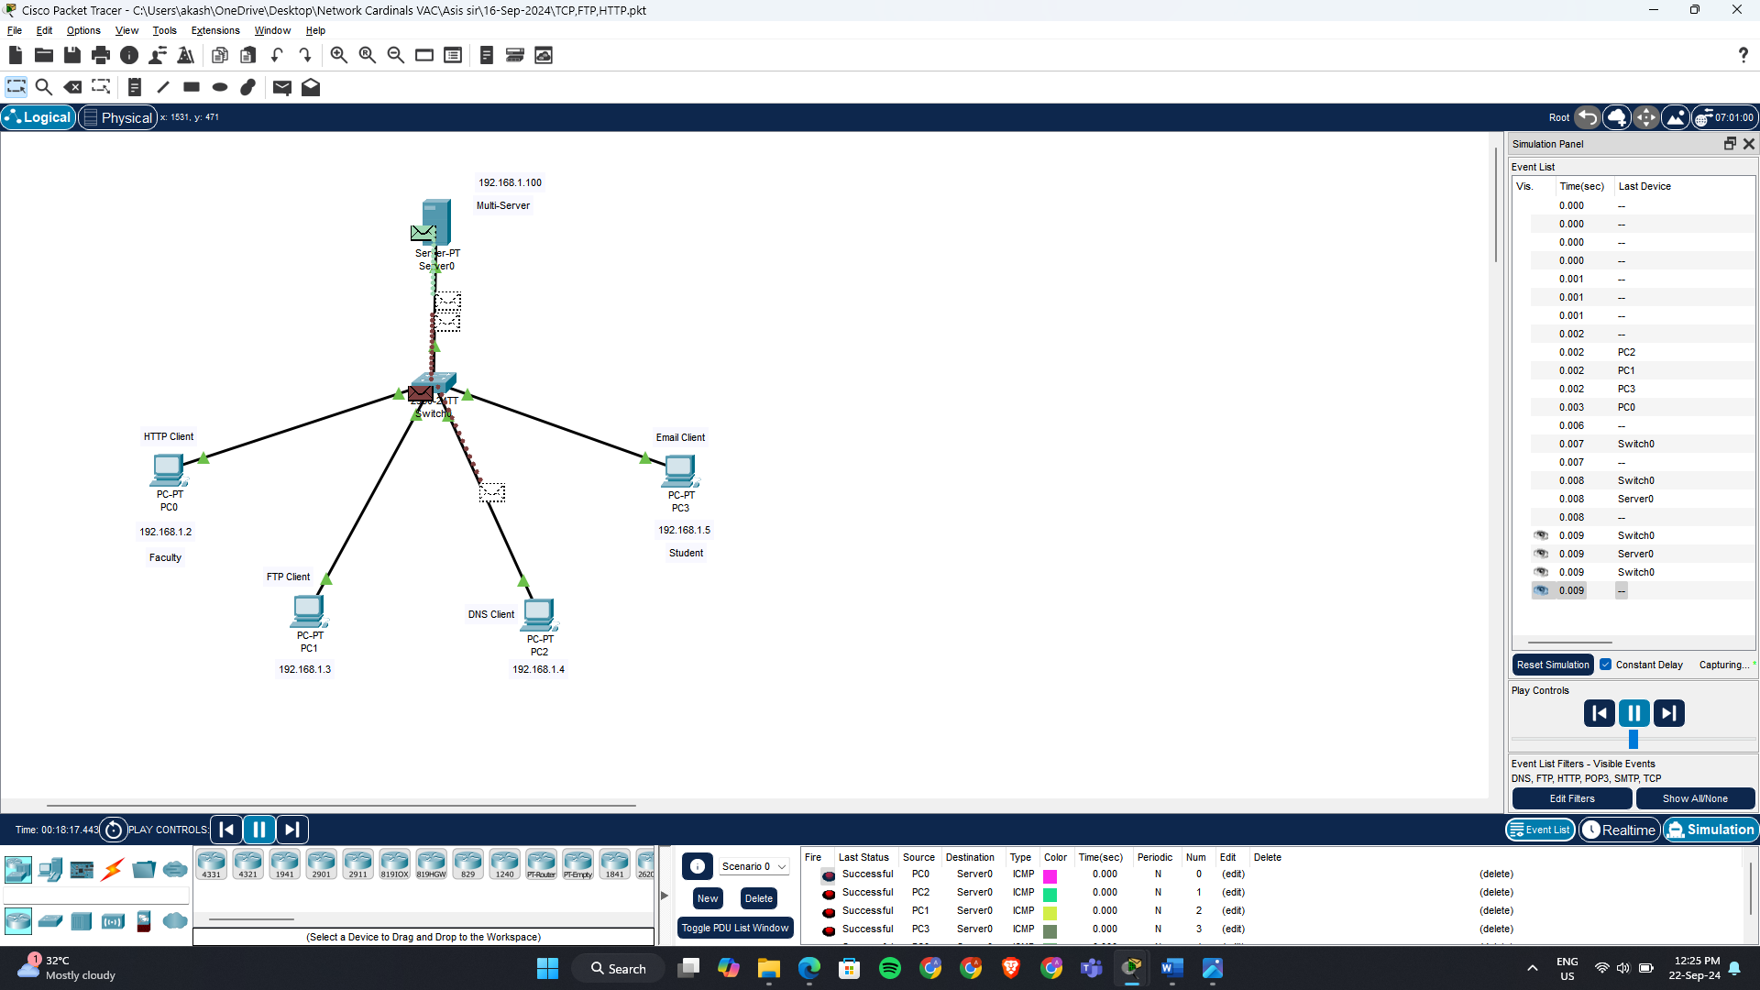

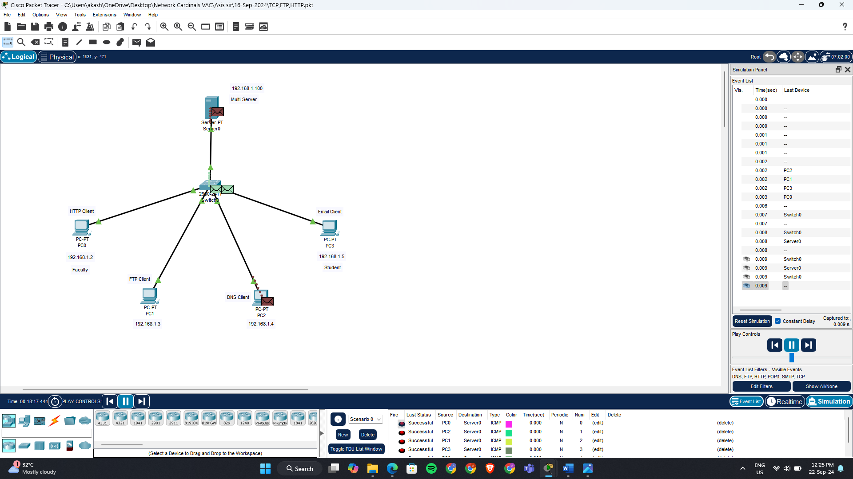

Q4. Implement ARP protocol for 10 computers and 1 switch. Show the ARP table modification (5 instances) of PC4 and PC8 during data transmission between them.

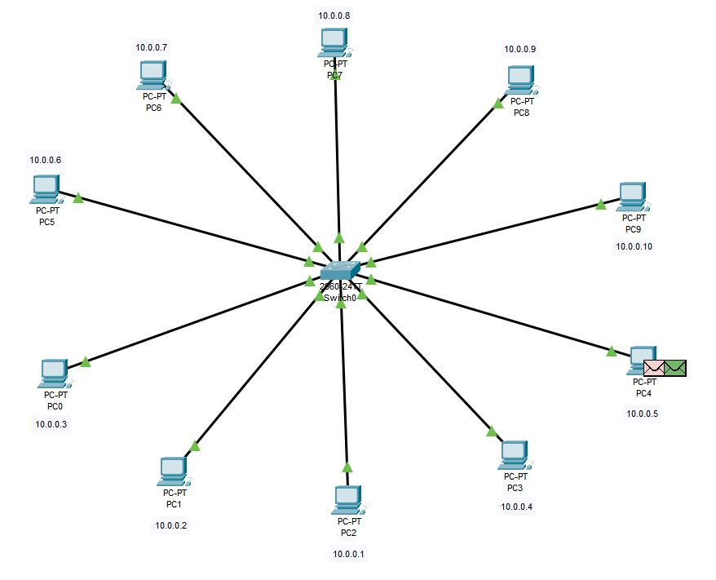

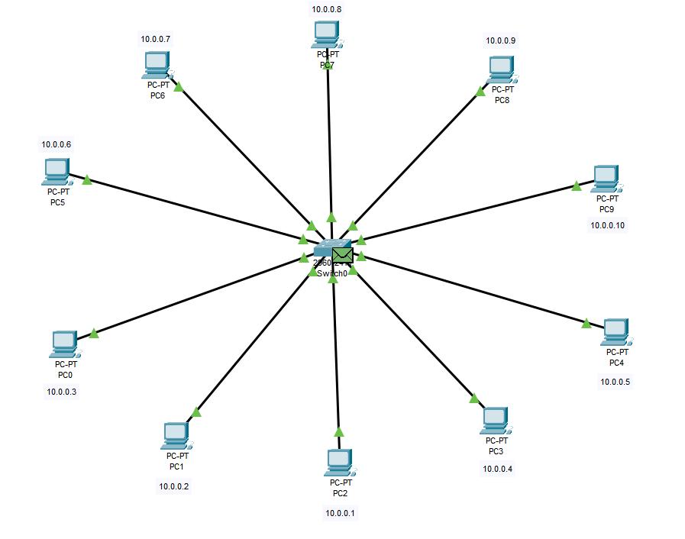

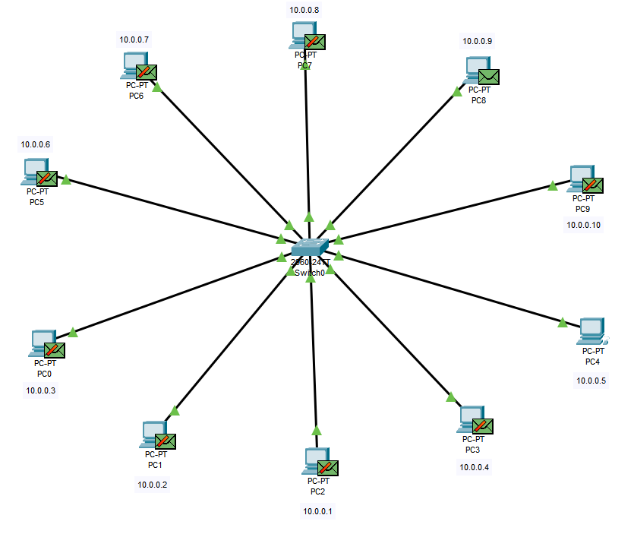

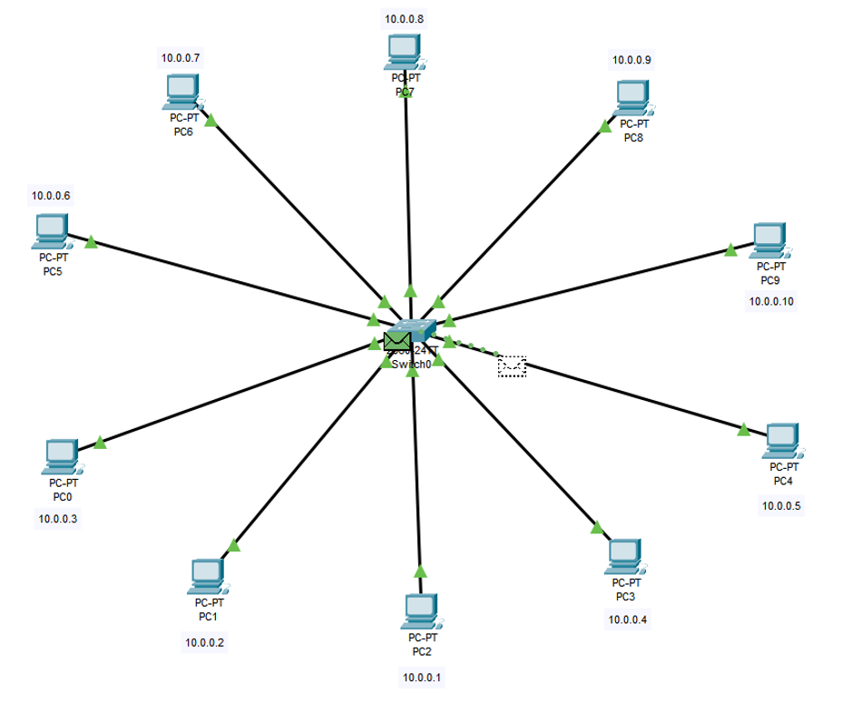

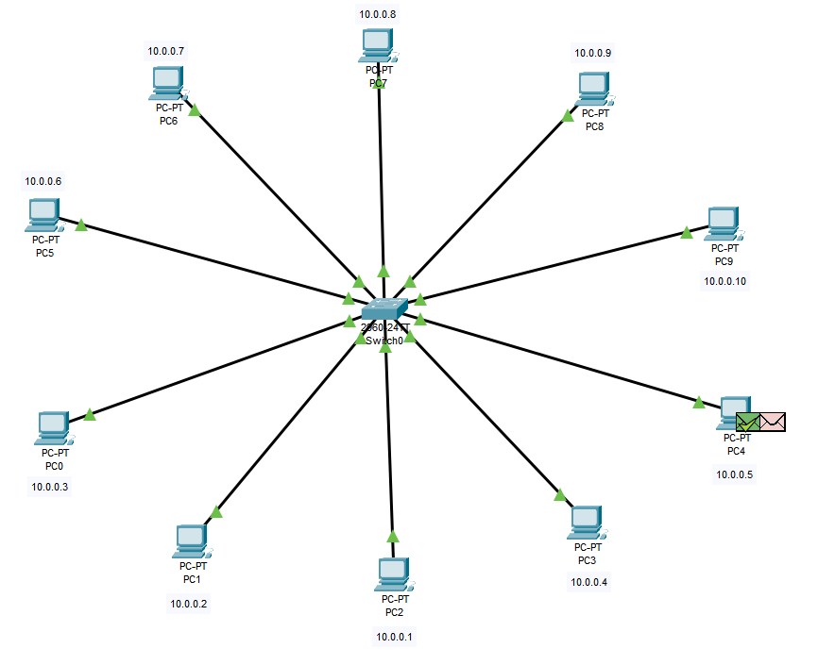

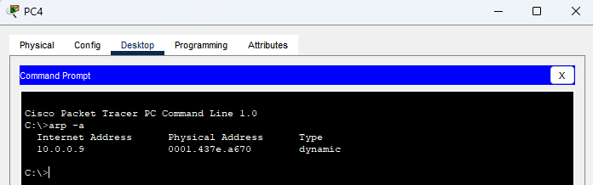

Q5. Implement OSPF protocol for 6 computers, 2 switches, and 3 routers. Show the sample screenshots (5 instances) for sending a packet from PC2 to PC6 available in another domain.

